Regional Festivals and Participative Events
Small Grants Scheme 2020
In County Meath

Public Forms
Guidelines and Application Form

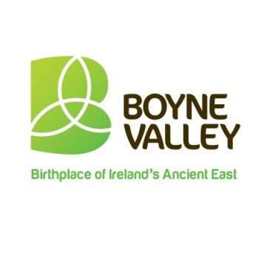 | 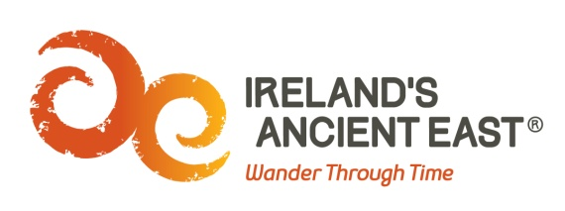
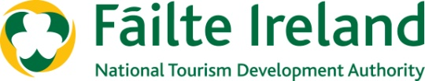

Guidelines

What is the purpose of the Regional Festivals and Participative Events Small Grants Scheme?
The key objective of the Fund is to provide support to festivals and participative event organisers that will harness overseas visitors for the benefit of local tourism. The fund is towards marketing costs and the Promoter must demonstrate that the festival or event has marketing and PR activity targeting overseas visitors to County Meath. The Fund is being administered by Meath County Council and is supported by Failte Ireland. The full fund available is €11,000 in total to be distributed amongst successful applicants.
What Must Successful Applicants Do Well?
- Help to build memorable visitor experiences in the locality, by adding vibrancy and colour to the area.
- The proposed festival/event programme will be comprehensive and professionally designed and motivating for the visitor.
- A clear business plan has been prepared to include a full income and expenditure budget for the event, and a comprehensive marketing and promotions plan.
- Where possible use digital technology to widen reach and impact.
- The profile of the organisers is appropriate to manage the calibre of the proposed event.
- The event or festival must incorporate the Boyne Valley and Ireland’s Ancient East brands.
- You must include Meath County Council, Boyne Valley and Ireland’s Ancient East Logos in all publications and on social media
- You must formally acknowledge Meath County Council and Fáilte Ireland’s contribution to the event.
- If possible provide a page of Information on places to stay during your event. (Must be Fáilte Ireland approved)
- If possible provide information on attractions and things to do in the wider Boyne Valley when promoting your event.

Festivals/participative events awarded funding must provide information to Tourist Information Offices in advance about the event so that information can be shared with visitors.
What Fund amounts are available?
Fund amounts will be for a minimum of €250 and a maximum of €2,000.00 and will be directly related to the number of overseas visitors that will be delivered. Overseas visitors will be deemed those who travel from outside of the Republic of Ireland including from Northern Ireland.
The Fund awards will be guided by the following scale with other relevant information provided in your application:
Fund Amount € | Minimum Number of Overseas Visitors Required
€250 | 10
€500 | 20
€750 | 30
€1000 | 40
€1250 | 50
€1500 | 60
€1750 | 70
€2000 | 80

Who is eligible to apply?
It is open to groups or organisations that are organising events / activities in 2020. To be eligible for funding, the event / project must:
- Deliver a number of incremental overseas visitors as per the above table (where incremental overseas visitors are those additional visitors over and beyond those which would normally visit the county).
- Demonstrate a capacity to deliver i.e. the Event Organiser(s) must provide evidence of and have a clear plan for tapping into international networks.
- Have the capability to promote the event and provide a potential for media coverage.
- Contribute at a local level to the county’s calendar of events in relation to attracting overseas visitors.
- Be either a new event which will take place in 2020 or an addition to an existing event which is being expanded to specifically deliver incremental overseas visitors.

N.B. There is no guarantee of funding for events which achieve the minimum eligibility criteria or for events which were previously funded under the Scheme. The fund is limited and eligible applications will be evaluated on a competitive basis. The fund is towards marketing costs and the Promoter must demonstrate that the festival or event has marketing and PR activity targeting overseas visitors to County Meath.
What types of Events will be funded?
Various types of Events will be considered for funding – however they must have a strong focus on international marketing and therefore attract overseas visitors to the Boyne Valley. They also must have the potential to be repeated.
The Regional Festival and Participative Events Programme is aimed at festivals and participative events that fit into one of the following categories:
- General festivals (i.e. literary, historic, traditional culture or family focused).
- Arts, Music & Theatre.
- Food & Drink.
- Sports & Outdoors.
- Business & Education.
- Other.
The following categories of festival and participative events are ineligible for this funding arrangement:
- Purely commercial events with limited tourism appeal.
- Agricultural shows and countryside fairs with limited tourism appeal.
- Spectator-based sporting events.
- Circuses and carnivals.
- Christmas fairs and markets.
What items and expenses are excluded from the fund?
- Infrastructural / tourism development projects / capital costs for the county
- Festivals which have already received funding under the Fáilte Ireland Regional Festivals Fund during 2020
- Spend on alcoholic beverages, fines, penalty payments, legal cost, audit fees, financial consultancy fees and wages and salaries of consultants
- Recoverable VAT, in kind contributions, fines, unpaid expenditure, cash expenditure
- Activities which have been or are being grant aided by other public sources including Meath County Council
- In general the cost of items for resale are ineligible
How do I apply?
You should apply directly to Meath County Council. Only completed submissions received via the approved application form will be considered. The completed form must be sent to Community Section, Meath County Council to communitygrants@meathcoco.ie.
A signed version of the application must be scanned in and then emailed (with the appropriate signature(s) of the organiser). You may also submit accompanying additional documentation with your completed application form as appropriate.

Applications must be received by 17.00 on Friday the 13th of March 2020.
If I am successful how do I draw down the Fund?
Payment will only be made after the event has taken place. In order to receive the payment, the successful applicant must complete a short Post Event Report Form (to be supplied by Meath county council) and provide the following:
- Visitor Book or Listing of overseas attendees and their country of origin
- Evidence that the event has taken place (e.g. photographic evidence)
- Receipts for the full costs
- A detailed breakdown of income (including grants) and expenditure

Please note that it the responsibility of the promoter to ensure GDPR compliance when collecting personal data. Funding not claimed by the agreed deadline will be cancelled.
How will I know if my group has been successful?
Successful applicants will receive a Letter of Offer. This letter will form the contract between Meath County Council and the organiser and will detail all conditions and requirements.
Acknowledgement
Once you have been notified that you have been successful in receiving funding, you must ensure that your event is promoted as part of this initiative and appropriate guidelines to support this will be included with the letter of offer.

2020
Regional Festivals & Participative Events Scheme
APPLICATION FORM
County / City Council you are applying for funding to: Meath County Council
APPLICANT DETAILS
Name of Group / Organisation
Address of Group / Organisation

NAME AND CONTACT DETAILS OF THE PERSON DEALING WITH THE APPLICATION
Name:
Telephone:
Email:
DETAILS OF PROPOSED EVENT
Name of Event:
Dates:
Location(s):
Is it a new event/ existing event?
TARGET AUDIENCE
Who are you inviting to your Event?

Please list details of the groups, associations, organisations as appropriate. (If you have a listing please attach and include in your application).

How have you identified the target group?

How will you promote the event?
Please attach a marketing plan/ further details

How many overseas visitors are you inviting? (please insert a number)

How many overseas visitors do you estimate will attend? (please insert a number)

What country/countries of origin will your target groups/ visitors come from?

Capacity to deliver
Do you have contacts, connections that will facilitate this event occurring? (If so, please detail). What structures are in place, who will oversee it etc.?

BRIEFLY DESCRIBE YOUR EVENT
Explain the rationale for its existence and how it will support the Community Tourism Diaspora Initiative.
(Keep to a maximum of 100 words max/ attach extra documentation)
Please give a breakdown of the events income |  | Description | Income
Please give a breakdown of the events expenditure |  | Description | Expenditure
Have you received or applied for other sources of public funding? (if so, please tick the appropriate box ) |  | Yes |  | No
If yes, please state the source and amount of funding.

Incomplete forms will NOT be considered
Disclaimer – please read carefully
It will be a condition of any application for funding under the terms and conditions of the Regional Festivals and Participative Events that the applicant has read, understood and accepted the following:
- Meath County Council shall not be liable to the applicant or any other party, in respect of any loss, damage or costs of any nature arising directly or indirectly from:
  - The application or the subject matter of the application.
  - The rejection for any reason of any application.
- Meath County Council shall not be held responsible or liable, at any time in any circumstances, in relation to any matter whatsoever arising in connection with the administration of activities.
- By submitting an application, applicants agree to the processing and disclosure of the applicant’s information by Meath County Council and to other third parties if required, for Fund administration, reporting, evaluation and audit purposes; and successful applicants further consent to the disclosure of this information (e.g. name of successful applicant, amount of award, event details, etc.) by these parties in connection with the marketing or promotion of the Fund. Meath County Council agrees to employ appropriate measures to keep applicants’ data safe and secure; to prevent its unauthorized or accidental disclosure, access or alteration; and to ensure that personal data will be processed only in accordance with the relevant provisions of the Data Protection legislation. (GDPR)

Declaration of Applicant(s)
We have read and understood the information and criteria applicable to the Fund and agree to comply in full therewith. I/we certify that all information provided in this application, and all information given in any documentation submitted in support of the application is truthful and accurate and that I have not applied to any other county council for funding for this Event. More than 1 group member must sign the application.

Signed: ______________________________Date: _________________

Name: (in block capitals):

__________________________________________________________

Signed: ______________________________Date: _________________

Name: (in block capitals):

__________________________________________________________

On behalf of: (organisation's name):

Email: communitygrants@meathcoco.ie
Applications must be received by 17.00 on Friday the 13th of March 2020.

