TYRONE GUTHRIE CENTRE REGIONAL BURSARY

This award is intended to fund a week long residential stay at the Tyrone Guthrie Artists’ Retreat in Annaghmakerrig, Co. Monaghan. The residency is open to artists of all disciplines, living in County Meath.

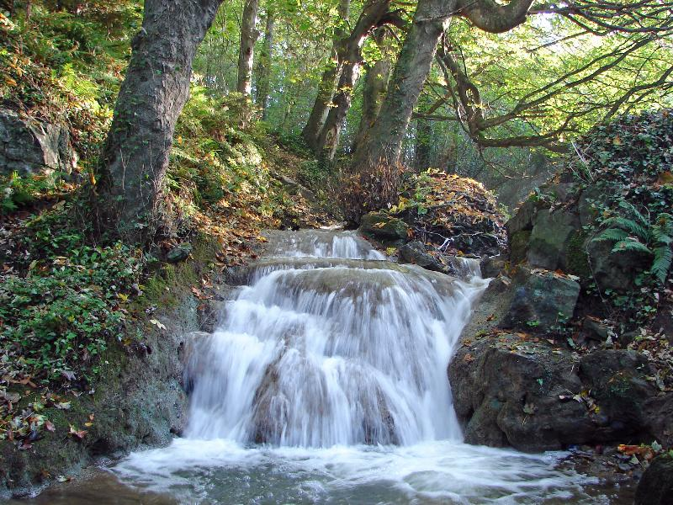

Completed Applications must be submitted by Post to:

Arts Office, Meath County Council, Innovation House, Railway Street, Navan, Co. Meath

No later than Thursday: 20th August 2020 @ 1pm

Please address application queries to: artsoffice@meathcoco.ie + 353 (0) 46 9097414

TERMS AND CONDITIONS:

- The Tyrone Guthrie Centre Regional Bursary is competition based and previously funded artists are not guaranteed repeat support. New applications must be made in respect of 2020 opportunities.

- Applications must be typed, handwritten applications will not be considered.

- Incomplete or late applications will not be considered.

- Artists applying for the Tyrone Guthrie Regional Bursary must be Meath based and must provide a valid eircode.

- The bursary entitles the successful applicant to a week-long residential stay in the Tyrone Guthrie Centre, Annaghmakerrig, Co Monahgan.

- The bursary is intended to assist professional artists work towards the completion of a particular project in a unique environment.

- Artists applying for the Tyrone Guthrie Regional Bursary should demonstrate considerable achievement in their chosen field.

- Awardees must credit Meath County Council in all publicity, on line, in print, on radio and TV.

- All supporting documentation must be clearly labelled with artist’s name and contact details and must include a short description outlining its relevance to the application.

- Unique or irreplaceable material should not be submitted. Meath County Council will not be held responsible for any such material. A stamped addressed envelope must be submitted if applicant requires the return of support documentation.

- All Tyrone Guthrie Regional Bursary awards will be made in accordance with the County Arts Development Plan 2019 - 2024.

- Meath County Council reserves the right to review, amend, revise or revoke this scheme at its own discretion at any time.

APPLICATION

Artist’s Name:

Artist’s Address:

Artist’s Eircode:

Artist’s Email:

Artist’s Phone:

Artist’s Website:

Artist’s principal practice relates to

Visual Art Theatre Music Literature Dance

Other Please state other

Has artist secured a Tyrone Guthrie Regional Bursary from MCC in the past? |  | Yes No
If Yes, please identify the year(s) grant was awarded |  | 2016 2017 2018 2019

Please use the space below to describe your artistic practice (300 words max)

Please use the space below to describe the project you wish to complete while at Annaghmakerrig (300 words max):

SUPPORT MATERIAL
Please tick the boxes below to identify the inclusion of listed support material with application
An up to date detailed artists CV
Up to 5 samples of recent work
Evidence of past accreditation given to Meath County Council Arts Office, if applicable
DATA PROTECTION
The personal information (data) collected on this form, including any attachments, (which may include the collection of sensitive personal data) is collected for the purpose of processing this application and any data collected is subject to Meath County Council’s privacy statement which can be found at http://www.meath.ie/Data Protection/

Meath County Council Arts Office regularly sends out information relating to opportunities and events.
I would like my contact information to be added to the Meath County Council Arts Office mailing list | Yes No

CHECKLIST

Application is completed in full

Application is signed

Labelled support material is included

Data Protection is completed

SIGNED DECLARATION
I, the undersigned, HEREBY DECLARE that all statements given by me on this Application Form are true, correct and without omission. Any false information given will disqualify my Application.

I have read, understand and agree to the terms and conditions of this application

Signed Date

__________________________ _________________________

___________________________________________________________________
For office use only

Date Received

Is application completed in full?

Is application signed?

Is support material included?

Is Eircode eligible?

Is application valid?

