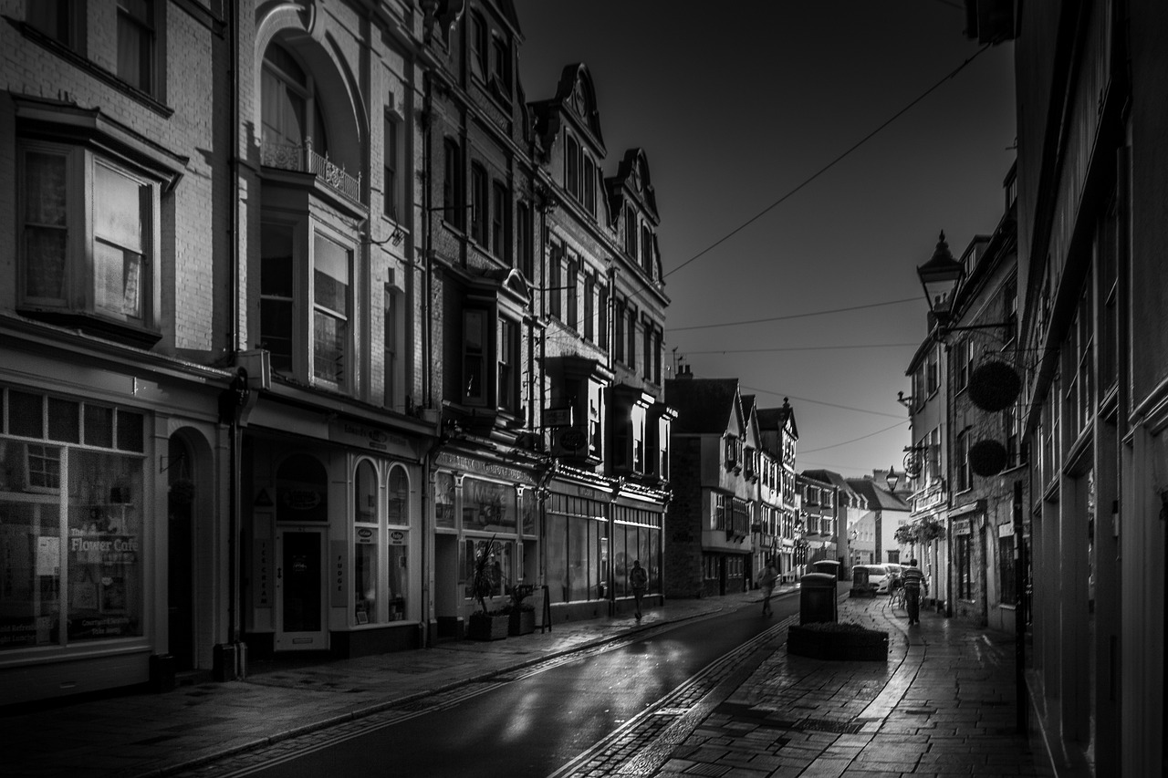

Meath County Council

Shop Front Improvement Scheme – Covid 19 affected retailers

Economic Development Section
Buvinda House,
Navan Co Meath
Reference Number – (Office Use Only)____________________
Name of Applicant:
v
Property address

(subject of application):

Business name
(currently operating from premises):

Contact name for application:
v
Contact Address:

v
Contact Phone Number:
Contact Email Address:
v
Type of Business:
v
Date in which building was
v
Constructed: (to nearest decade)
Estimated start date:
v
Estimated completion date:
v
Estimated cost of project:
v
Planning Application number: (if applicable)

v
Are you the owner of the property? Yes No

If No please submit written approval from the owner of the property to apply for works

Please provide a detailed breakdown of the proposed project:
_____________________________________________________________________________________________________________________________________________________________________________________________________________________________________________________________________________________________________________________________________________________________________________________________________________________________________________________________________________________________________________________________________________________________________________________________________
________________________________________________________________________________________________________________________________________________________

Please note:
- Applicants should assess their own eligibility inclusive of the requirement for planning (please contact the Planning Section should you be unsure 046 9097500)
- A site visit(s) may take place throughout the process to ensure work is in line with the outlined proposed works

Applications should be accompanied by the following:
- Photograph(s) of existing shop front
- Sketch/Plan of proposed shop front changes
- Indication of the type of materials and colour scheme proposed
- A written quotation for the proposed works
- Written proof of ownership/approval letter & contact details of the owner
- Dates of closures and details of projected losses due to Covid 19

DECLARATION
I/WE declare that the information provided is true and correct
Name (Block Capitals): Position Held:

Signed: ___________________ Date: ________

All queries should be directed to economic@meathcoco.ie

