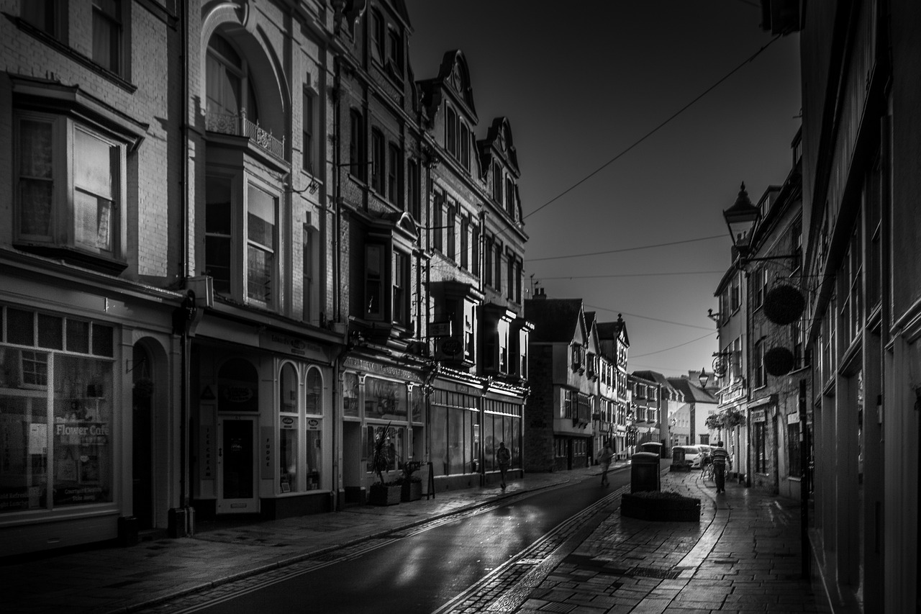

Meath County Council

Shop Front Improvement Scheme – Covid 19 affected retailers

Economic Development Section
Buvinda House,
Navan Co Meath

Shop Front Scheme designed to assist those affected by Covid-19 Closures.
Covid-19 has caused massive disruption to the retail sector a sector which is heavily reliant on face to face contact with consumers.

This funding is being provided from Economic Development, Make It Meath fund, in recognition of the fact that a building’s facade makes a big impact on our town centres. They help form people’s first impressions of a shop & the town centres they occupy, so their condition can really have an impact of a town’s image. Smart shop fronts will make a town feel more prosperous, improve its image and contribute towards a stronger sense of identity and pride within our centres.
Proposals for funding do not have to involve a significant or expensive change. Simple jobs like repainting a shop front, replacing a shop sign or window dressing improvement may qualify. Each application will be assessed on its own merits and any job that will enhance the town’s character may qualify for grant aid.
This grant will only be available to those retailers who suffered some sort of closure or calculatable losses during imposed Covid-19 measures.

Terms and Conditions

Grants are available up to a maximum of €5,000 or 50% of the eligible costs (example approved project cost = €2000 we pay €1000
- Details of proposed works including drawings or even minor details to the facade should be included with the completed grant application form
- Retrospective applications for works already undertaken will not be accepted
- An itemised list and quotations must be provided for proposed work
- Grants will only be offered to independently owned businesses
- Permission must be sought from the owner of the premises should there be a lease agreement in place. Consent must be submitted with the application form
- Planning permission may be required for some applications & should your building be a protected structure contact should be made with the heritage officer
- The grant is payable after the completion of the works
- Grants will only be paid upon the submission of receipts
- Rates must have been up to date prior to the Covid-19 pause on rates
- In the event of oversubscription of the fund the Team will assess with priority the one’s in greater need which if improved would positively impact the area visually

Eligible Works will Include:

- Repair & reinstatement of any part of the front fixture that is visible from the street. We must encourage the reinstatement and retention of architectural or historical features that have formed the part of the building but that may have aged or been damaged over time
- Repainting of shop fronts in suitable colours will be supported
- Installation of suitable exterior lighting
- Pedestrian improvements in particular in support of the age friendly initiative.
- Removal of and replacement of neon/LED signs, banners and other inappropriate signage affixed to front elevations visible from the street with replacement of more appropriate shop front design.

All queries should be directed to economic@meathcoco.ie

