Green Kilometre Participation Form
Meath County Council is aware that there are many groups and individuals around the county who would like to contribute to their local community, especially since Covid. An increase in walking and cycling since the lockdowns began has made many people aware of both the litter that may be seen along the roadside, but also the wildlife that exists in the hedgerows and roadside margins. People may also notice built heritage features such as old gates, water pumps etc. As a response to this we have created the Green Kilometre scheme. With over 3,600 kilometres of roads in the county, there are plenty of opportunities to get involved! The scheme invites individuals/groups to choose approximately a kilometre (or longer) stretch of road/loop in their area- preferably a quiet, local road in terms of safety. The group or individual would then commit to maintaining the chosen stretch over the course of the year.
Incentives of some native trees, litter pickers, bags and gloves are on offer for all participating individuals/groups and if you wish we can arrange for an adviser (when restrictions allow) to visit to give advice in relation to planting, care of heritage features etc, where applicable, on your stretch of road.

Most importantly the scheme is an opportunity for you or your community to work together on a project which benefits everybody.

The following are examples of the work/activities that can be included:
- Removing litter
- Planting appropriate native trees and shrubs
- Restoring heritage features such as old farm gates or walls (permission from landowners should be obtained first and protected structures should only be maintained following professional advice)
- Report illegal dumping
- Improving hedges (sections of traditional hedge laying would be very welcome)
- Note that hedge cutting is banned from March 1st to September 1st.
- Cleaning and maintaining signs

We look forward to seeing many green kilometres around the county in 2021 and beyond!
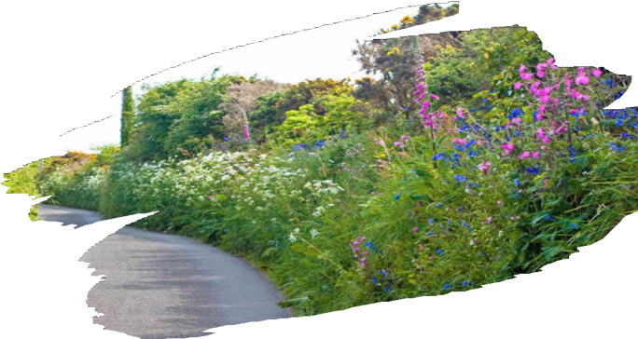
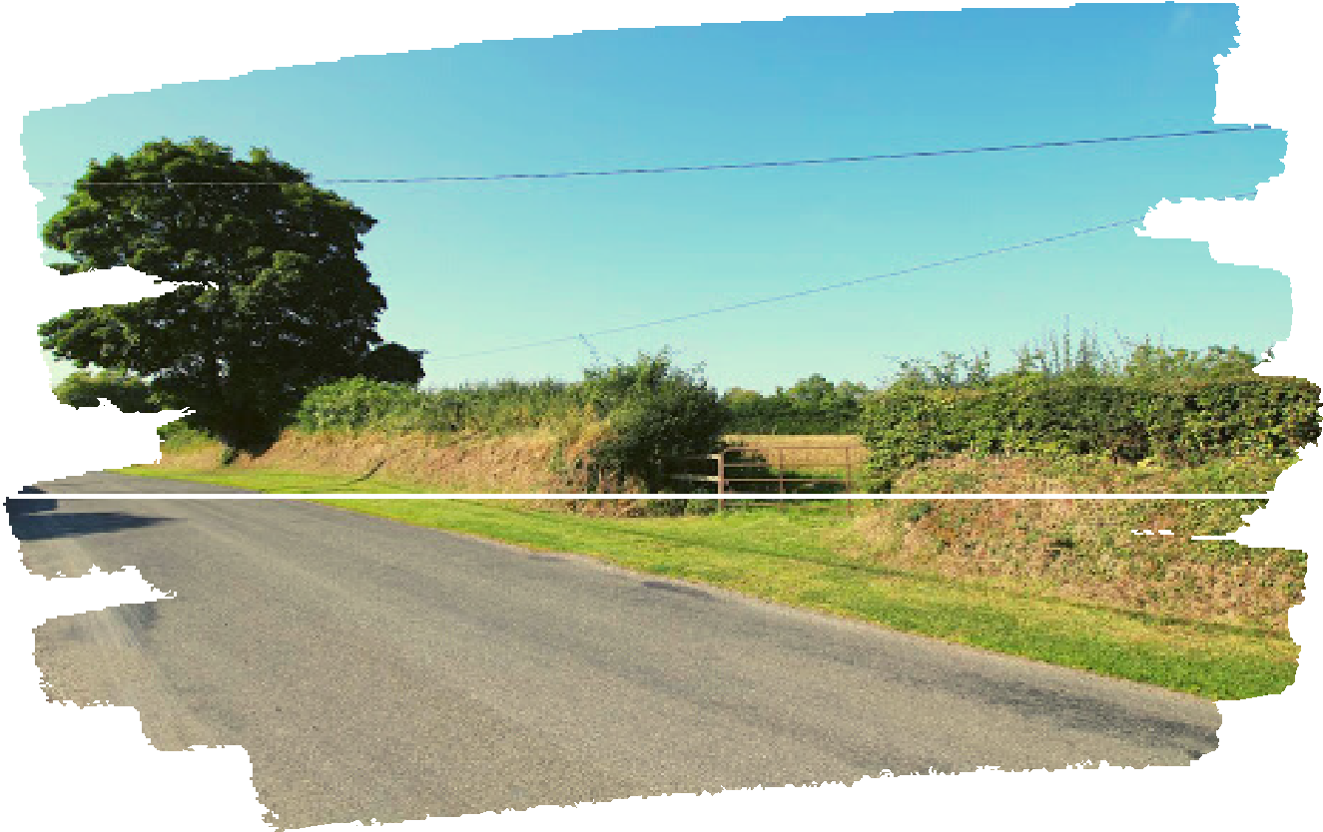

Useful Resources
To report illegal dumping where there is potential evidence (in the dumped waste or a vehicle registration or other identifier), email environment@meathcoco.ie or phone 046 9097200.
To get pickers, bags and gloves for clean-ups email: environment@meathcoco.ie
Identify native wildflowers: www.wildflowersofireland.net
Find out about the National Pollinator Plan, see www.pollinators.ie
Identify invasive species such as Japanese knotweed: www.invasivespeciesireland.com
Learn about hedge laying (traditional hedge cutting techniques): www.hedgelaying.ie
Manage waste, find out what to recycle and where, visit www.mywaste.ie

How do I get involved?
Send us your completed participation form, which can be submitted at any time of the year.
Name of individual / group: _________________________________

Contact Name: __________________________________________

Contact Number: _________________________________________

Contact Email: ___________________________________________

Address/Location of Green Kilometre: __________________________________________

Include map, townland, eircodes etc. to assist in locating:

