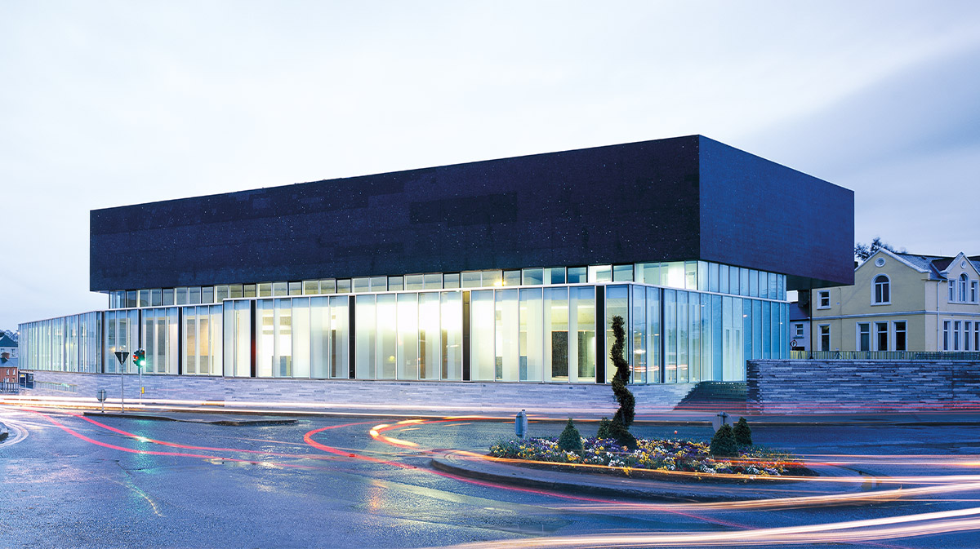

Launch of the

National Healthy Age Friendly Homes Programme

By Mary Butler TD. Minister of State, Department of Health with responsibility for Mental Health and Older People
and
Peter Burke TD. Minister of State with responsibility for Local Government and Planning
12.00pm | Event Opening  Catherine McGuigan, Chief Officer, Age Friendly Ireland
12.05pm | Welcome Address  Cllr Sean Drew, Cathaoirleach, Meath County Council
12.10pm | Overview of the Healthy Age Friendly Homes Programme  Andrew Hannigan, Sláintecare, Department of Health  Followed by a short video demonstrating the Healthy Age Friendly Homes Programme.
12.25pm | Age Friendly Ireland | Role of Local Government in Coordinating Support Services for Older People  Jackie Maguire, Chief Executive, Meath County Council & Host of Age Friendly Ireland Shared Service
12.35pm | Welcoming the Healthy Age Friendly Homes Programme on behalf of Older People in Ireland  Kitty Hughes, Chair of the National Network of Older People’s Councils
12.40pm | Official Launch | A Collaborative Approach to Supporting Older People in Ireland  Minister of State, Peter Burke, TD, Department of Housing, Local Government & Heritage  Minister of State, Mary Butler, TD, Department of Health
1.00pm | Close

Virtually from the Solstice Arts Centre | Tuesday 13th July 20212 @ 12pm

