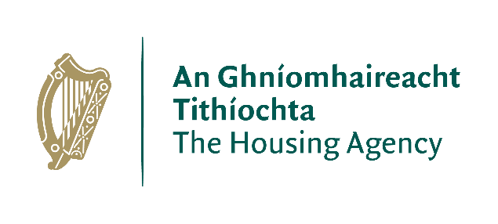

Briefing Note on Targeted Leasing Initiative
Background
The Targeted Leasing Initiative is a new leasing arrangement that seeks to achieve the following policy objectives:

- Facilitate and expedite additional permanent social housing.
- Provide additional supply targeted at areas of greatest need; and
- Prioritise State support for homes aligned with the needs of the social housing waiting list.

Overview
The initiative is being carried out via an Expressions of Interest (EOI) issued via www.etenders.gov.ie. The objective of this call for expressions of interest is to explore the possibility of delivering up to an additional 1,000 homes for social housing through a time-bound and limited leasing intervention that will deliver better value for money for the State than existing standard leasing. The Long-term Leasing scheme under Housing for All remains unchanged and is still being phased out over the lifetime of Housing for All to the end of 2025.

Proposers have two options under which to submit proposals as part of the EOI:

Option 1: Standard leasing with a maximum term of 25 years, with proposers to submit proposals for discount to market rents over and above the standard leasing terms (15/20%) currently in operation.

Option 2: Standard leasing up to a maximum of 30 years for the standard discount (15/20%) currently in operation with transfer of the leased properties to the Local Authority at the end of the lease term at a discount to the open market value of the leased properties. Proposers will be required to submit a proposed percentage discount on the future open market value of the leased properties.

Operation of the Initiative
The new initiative was launched on 15th July 2022 by means of an EOI with a deadline for submissions to The Housing Agency of 15th August 2022. The EOI invites proposers to indicate their capacity to provide proposals with a minimum of 20 and a maximum of 150 properties in a Local Authority area for the purposes of the initiative.

- Role of the Housing Agency
The Housing Agency manages and administers the initiative on behalf of the DHLGH. The Housing Agency will be the national coordinator for the initiative. The Housing Agency oversees the administration of the leasing arrangements including the drafting of the Agreement for Lease (“AFL”) and Lease (“Lease”) and will manage the liaison between the Local Authority and the proposer including managing the due diligence on each proposal up until the signing of the AFL between a Local Authority and a proposer.

- Role of Local Authorities
The Local Authority is acting in its capacity as a Housing Authority. As such, Local Authorities will be asked by the Housing Agency to determine the suitability of the proposed properties, having regard to the types of properties offered, the requirement for social housing in the area and the criteria set out in the Local Authority’s Development Plans, including sustainable communities’ considerations. Any proposed lease arrangement under the initiative will be between the Local Authority and the proposer. The Local Authority will pay a rent to the proposer, which will be set at a percentage of the market rent. The Local Authority will be the landlord to the household and will collect a differential (income based) rent from the household.

- Role the Proposer
The proposer will submit details of properties it proposes for the initiative as per the submission requirements set out in this EOI. Under the terms of the lease for each property, the proposer will be responsible for all structural repairs and maintenance of the exterior of the property including the roof for the duration of the lease.

- Rent
Proposers will be required to include submitted rents for each of the properties they propose leasing under these arrangements. Under the EOI, proposers are requested to submit an enhanced discount on the Open Market Rent for Option 1. The Housing Agency will conduct a valuation through the SCSI or IPAV which will be used in the determination of the market rent. The lesser of the two rents between that submitted by the proposer and the valuation carried out by the Housing Agency will be the proposed rent. Once the proposed rents have been accepted and agreed, this rent with the appropriate discount applied will be inserted in the AFL/Lease, with indexation operating from the submission date using the Harmonised Index of Consumer Prices (“HICP”).

Next steps
Proposers have until the 15th August 2022 to submit proposals under the EOI. The Housing Agency will then coordinate and administer the review and assessment of the submissions for participation in the initiative and will contact the respective Local Authorities in this regard.

Further queries in relation to this initiative can be directed to The Housing Agency: leasing@housingagency.ie

