Meath County Council Pride of Place Initiative
Application Form 2024
Please complete and submit to Pride of Place, Community Section, Meath County Council, Buvinda House, Navan, C15 Y291 or e-mail to prideofplace@meathcoco.ie by 5pm on Friday 31st May 2024
Section 1 – Applicant Details & Contact Information
Category 1 - Housing Estate/Apartment Complex/Residential Streetscape
Please read the category details, Judging Criteria & Marking for this category at the bottom of this document before completing this form, please use capital letters and please complete every section. You can submit photographs with your application, a picture paints a thousand words.
Name of applicant (Person filling in the form NOT the group name):
Name of Estate/Apartment Complex/Streetscape:
Contact person for all correspondence:
Address for correspondence:
Eircode:
Municipal District: Ashbourne Kells Navan Laytown/Bettystown Ratoath Trim
Phone number:
Nominated email Address:
Please give details of group social media/website pages:
Is your group affiliated to Meath Public Participation Network? Yes No
If not, would you like to register your group with Meath PPN? Yes No
Section 2 - Category

Please tick ONE below
Small Housing Estate (1 to 30 houses)
Medium Housing Estate (31 to 70 houses)
Large Housing Estate (71 to 200 houses)
Extra Large Housing Estate (201 + houses)
Apartment Complex
Residential Streetscape

Please tell us what you have done this year to improve the look of the area including strategies to deal with dog fouling, pollinator planting in green areas, encouraging biodiversity friendly gardens in the area etc.
Section 3 – General Appearance

Please describe your litter and graffiti strategy this year
Section 4 – Litter and Graffiti

Section 5 – Community Participation
Please describe your group? How many volunteers do you have?

How do you recruit more? How do you encourage social inclusion in the group?

Please describe all initiatives used to engage youth in your area this year

Describe any collaborations you have had with other groups/local businesses this year
Section 6 – Environmental Initiatives & Biodiversity Initiatives
Describe any environmental & biodiversity projects completed or underway this year.

How do you fund your projects?
Section 7 - Funding
Judging Criteria & Marking

General Appearance 30 Marks
- Presentation of area/ houses/ gardens, number of biodiversity friendly gardens, work done to help people in the area increase biodiversity on the street and in gardens.
- Road and street appearance, pollinator planting, weeding where needed, absence of dog fouling.
- Green areas used for tree planting, pollinator planting and good use of space for biodiversity and users.
Litter and Graffiti 20 Marks
- Are areas litter and graffiti free on inspection.
- What is the litter reduction strategy during the year.
- What is the graffiti prevention & removal strategy during the year.
Community Participation 20 Marks
- Numbers involved in the group and work done to increase numbers and ensure social inclusion.
- Youth engagement such as workshops/ photo competitions etc.
- How do you communicate with others i.e. social media/emails etc.
- Collaborations with businesses in the area.
- Collaboration with other groups such as other to share ideas or help out another area particularly if you help in a disadvantaged area or high litter area outside your usual ground covered.
Environmental Best Practice 10 Marks
- Water awareness
- Waste awareness including green waste
- Environmental initiatives
- Sustainability awareness and initiatives
- Initiatives shown to minimise and manage dog fouling.
Biodiversity Projects 10 Marks
- What has been done to increase biodiversity in the area?
- How has awareness been raised about harmful chemical use?

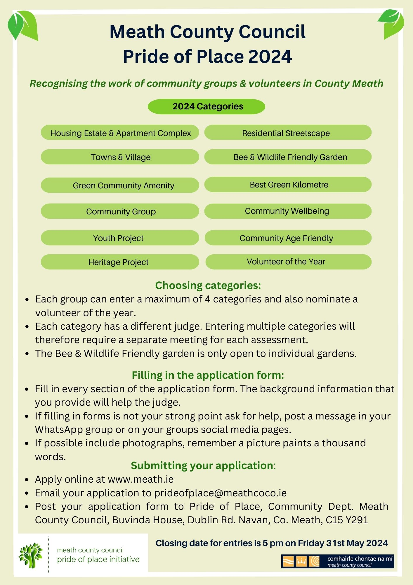
Awards - County & Municipal District award (CMD)
County only award (C)
Municipal District only award (MD)
Cat 1 - Housing Estates/Apartment Complex/ Residential Streetscape (CMD)
  - Small Housing Estates 30 houses or less
  - Medium Housing Estates with between 31 and 70 houses
  - Large Housing Estate with between 71 and 200 houses
  - Extra Large Housing Estate with more than 201 houses
  - Apartment Complexes located in County Meath
  - Residential Streetscape: A number of residential houses along a village or town street.
Cat 2 - Towns & Villages (CMD)
  - Village/Townland Population < 500
  - Small Town Population 500-1500
  - Large Town Population 1501 – 4000
  - Extra Large Town Population >4001
Cat 3 – Bee & Wildlife Friendly Garden (MD)
This award is for the best bee and wildlife friendly gardens. It is recommended that as much information as possible about the garden is included in the application form e.g. wildlife & bee friendly initiatives, description of the garden design, planting programme, features, theme, any environmental and biodiversity initiatives etc. as well as photographs which show the garden at its best. Sharing hints and tips will also earn marks.
Cat 4 – Green Community Amenity (CMD)
This award is designed for community areas, initiative or projects that don’t meet the criteria for the other categories. These may include but are not restricted to allotments, walkways, riverways, community gardens etc. These amenities must be not-for-profit and be available to the community. This category would also be open to previous Best New Group entrants.
Cat 5 – Green Kilometre (CMD)

This new award is designed for community groups who are currently part of the Green Kilometre scheme. The scheme invites individuals/groups to choose approximately a kilometre (or longer) stretch of road/loop in their area- preferably a quiet, local road in terms of safety. The group or individual would then commit to maintaining the chosen stretch over the course of the year. Litter pickers, bags and gloves are on offer for all participating individuals/groups. For more information about the scheme or to join go to www.meath.ie/council/council-services/environment
Cat 6 – Community Group (CMD)
Groups should show how they identified the need for the project that they have undertaken and how it benefits their local area.
Cat 7 – Community Wellbeing (CMD)
The community is recognised as a powerful setting to promote positive mental health and wellbeing. This category recognises and celebrates organisations or individuals that have developed initiatives (projects, activities, facilities) that promote positive mental health and wellbeing in their community.
Cat 8 – Youth Project (CMD)
Youth Groups must be able to demonstrate how their project enhances or benefits their local community. The project should show an emphasis on diversity and inclusion as well as an awareness of their local area.
Cat 9 – Community Age Friendly (CMD)
This award will be awarded to the best age friendly initiative in the Municipal District. We want to hear about Initiatives that are innovative, collaborative, are responsive to the needs of our older population and are contributing to making the community a great place in which to age. Projects that support older people to continue to play an active role in community life and enable them to feel safe and secure in their homes and in the wider community. An Age Friendly initiative is one that has a meaningful impact on the lives of older people in the community, where their views, interests and needs are catered for. Consideration will also be given where a group links in with other agencies or committees e.g. Meath OPC.
Cat 10 – Heritage (CMD)
This award is for any projects or works that gather information, conserve or promote an awareness and understanding of the natural, built or cultural heritage of an area (whether in a rural or urban setting). Our heritage encompasses historic buildings, monuments, museums, heritage objects and collections, landscapes, seascapes, native flora and fauna and wildlife habitats (e.g. woodlands) geology, heritage parks and gardens, inland waterways or local history/genealogy and folklore.
Cat 11 – Volunteer of the Year (MD)
This award will be adjudicated based on the information given on the application form. Therefore, please ensure to give as much information as possible about the person and why they should be considered for Volunteer of the Year. A person cannot nominate themselves.
Conditions and Guidelines
• Groups may apply for a maximum of four categories plus a Volunteer of the Year nomination, a separate application form must be submitted for each entry.
• In implementing this initiative, Meath County Council is working within the public sector equality and human rights duty, and seeks projects that engage the values of dignity, inclusion, and democracy as set out and defined in its equality and human rights values statement, available on www.meath.ie
• It is expected that participating groups are inclusive, participative and accessible in their structure and operation.
• Late applications will not be accepted. Please return completed application forms to the Community Department, Meath County Council, Buvinda House, Dublin Road, Navan, Co. Meath, C15 Y291 or by email prideofplace@meathcoco.ie by 5pm on Friday 31st May 2024
• Any not-for-profit community or voluntary group can apply. Commercial organisations and individuals are not eligible to apply.
• Additional information, photos, plans may be included separately if required.
• Please note that incomplete applications will be returned to you for completion.
• Information provided is subject to the provisions of the Freedom of Information Acts. Should you wish that any of the information, supplied by you, not be disclosed please specify the reasons for its sensitivity and you will be consulted prior to any release.
• Pride of Place adjudication will take place in June, July & August 2024 Monday – Friday, during business hours. Please ensure that you include as much information as possible in your application form to reflect your groups work including photos as appropriate. Where photos are submitted which contain individuals, ensure permission has been sought and granted.
• The judging date will be arranged at least two weeks in advance and every effort will be made to accommodate groups with a suitable date and time.
• Please note that there is a team of adjudicators who judge the different categories so depending on the categories a group applies for it may be necessary to speak with different adjudicators on different dates.
• The contact person and address listed on this form will be used for all correspondence regarding the application.
• A group representative must be available to speak with the adjudicator on judging day; failure to do so may mean that the adjudicator cannot fully judge the entry and the application can no longer be considered.
• The ‘Applicant Details and Contact Information’ section of this application is required to be completed for corresponding with the applicant and this personal information will not be shared with a third party. The questions relating to membership of the PPN are optional questions and if not completed, the application may still be eligible. If the remainder of the ‘Applicant Details and Contact Information’ section of this application is not completed in full, the application may not be processed as part of this scheme. In relation to the length of time that this personal information will be kept by Meath County Council, applications received will be held for the duration of program plus 1 year.
• The awards nights will take place during September, October and November. Details of dates, format and location will be confirmed later in the year.

