Regional Festivals and Participative Events
Small Grants Scheme 2024
In County Meath

Public Forms
Guidelines and Application Form

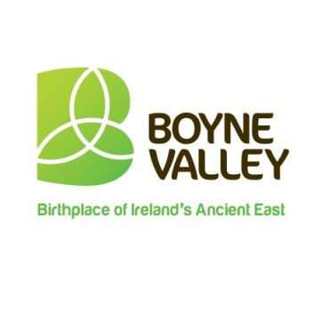 | 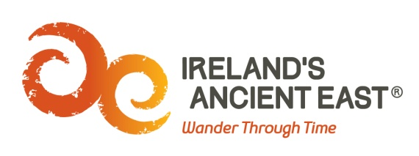
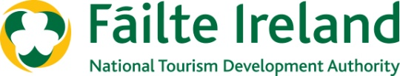

Guidelines

What is the purpose of the Regional Festivals and Participative Events Small Grants Scheme?
The Regional Festivals Programme aims to support Festivals and Participative Events that will drive domestic tourism and help to improve the visitor experience. They key objectives are:
- To attract and develop domestic and international visitors to the area in the shoulder season
- To increase bed-nights and benefit the local economy
- To raise awareness of the region internationally
The Fund is being administered by Meath County Council and is supported by Failte Ireland. The full fund available is €11,000 in total to be distributed amongst successful applicants.
What Must Successful Applicants Do Well?
- Help to build memorable visitor experiences in the locality, by adding vibrancy and colour to the area.
- The proposed festival/event programme will be comprehensive and professionally designed and motivating for the visitor.
- A clear business plan has been prepared to include a full income and expenditure budget for the event, and a comprehensive marketing and promotions plan.
- Where possible use digital technology to widen reach and impact.
- The profile of the organisers is appropriate to manage the calibre of the proposed event.
- The event or festival must incorporate the Boyne Valley and Ireland’s Ancient East brands.
- You must include Meath County Council, Boyne Valley and Ireland’s Ancient East Logos in all publications and on social media
- You must formally acknowledge Meath County Council and Fáilte Ireland’s contribution to the event.
- If possible provide a page of Information on places to stay during your event. (Must be Fáilte Ireland approved)
- If possible provide information on attractions and things to do in the wider Boyne Valley when promoting your event.

What Fund amounts are available?
Fund amounts will be for a minimum of €250 and a maximum of €2,000.00 and will be directly related to the visitor impact information and visitor numbers.
Who is eligible to apply?
It is open to groups or organisations that are organising events / activities in 2024. To be eligible for funding, the event / project must:
- Demonstrate a capacity to deliver i.e. the Event Organiser(s) must provide evidence of and have a clear plan for tapping into international networks.
- Have the capability to promote the event and provide a potential for media coverage.
- Contribute at a local level to the county’s calendar of events in relation to attracting overseas visitors.
- Be of benefit to the local economy and drive the economic contribution of tourism
- Be either a new event which will take place in 2024 or an addition to an existing event which is being expanded to meet demand.

N.B. There is no guarantee of funding for events which achieve the minimum eligibility criteria or for events which were previously funded under the Scheme. The fund is limited and eligible applications will be evaluated on a competitive basis.
What types of Events will be funded?
Various types of Events will be considered for funding – however they must have a strong focus on international marketing and therefore attract overseas visitors to the Boyne Valley. They also must have the potential to be repeated.
The Regional Festival and Participative Events Programme is aimed at festivals and participative events that fit into one of the following categories:
- General festivals (i.e. literary, historic, traditional culture or family focused).
- Arts, Music & Theatre.
- Food & Drink.
- Sports & Outdoors.
- Business & Education.
The following categories of festival and participative events are ineligible for this funding arrangement:
- Purely commercial events with limited tourism appeal.
- Agricultural shows and countryside fairs with limited tourism appeal.
- Spectator-based sporting events.
- Circuses and carnivals.
- Christmas fairs and markets.
What items and expenses are excluded from the fund?
- Infrastructural / tourism development projects / capital costs for the county
- Festivals which have already received funding under the Fáilte Ireland Regional Festivals Fund during 2024
- Spend on alcoholic beverages, fines, penalty payments, legal cost, audit fees, financial consultancy fees and wages and salaries of consultants
- Recoverable VAT, in kind contributions, fines, unpaid expenditure, cash expenditure
- Activities which have been or are being grant aided by other public sources including Meath County Council
- In general the cost of items for resale are ineligible
How do I apply?
You should apply directly to Meath County Council. Only completed submissions received via the approved application form will be considered. The completed form must be sent to Community Section, Meath County Council to communitygrants@meathcoco.ie.
A signed version of the application must be scanned in and then emailed (with the appropriate signature(s) of the organiser). You may also submit accompanying additional documentation with your completed application form as appropriate.

Applications must be received by 5 pm on Friday 22nd March 2024.

If I am successful how do I draw down the Fund?
Payment will only be made after the event has taken place. In order to receive the payment, the successful applicant must complete a short Post Event Report Form (to be supplied by Meath county council) and provide the following:
- Evidence that the event has taken place (e.g. photographic evidence)
- Receipts for the full costs
- A detailed breakdown of income (including grants) and expenditure

Please note that it the responsibility of the promoter to ensure GDPR compliance when collecting personal data. Funding not claimed by the agreed deadline will be cancelled.
How will I know if my group has been successful?
Successful applicants will receive a Letter of Offer from Meath County Council. This letter will form the contract between Meath County Council and the organiser and will detail all conditions and requirements.
Acknowledgement
Once you have been notified that you have been successful in receiving funding, you must ensure that your event is promoted as part of this initiative and appropriate guidelines to support this will be included with the letter of offer.

2024
Regional Festivals & Participative Events Scheme
APPLICATION FORM
County / City Council you are applying for funding to: Meath County Council
APPLICANT DETAILS
Name of Group / Organisation
Address of Group / Organisation

NAME AND CONTACT DETAILS OF THE PERSON DEALING WITH THE APPLICATION
Name:
Telephone:
Email:
DETAILS OF PROPOSED FESTIVAL/EVENT
Name of Event:
Dates:
Location(s):
Is it a new event/ existing event?
Description of the Festival
(150 words max)
Festival 2024 Highlights
Outline any changes to Festival Programme in 2024 from previous festivals
VISITOR IMPACT
Provide a profile of your visitors –whether it is local, domestic and/or international and attribute a percentage to each. Provide insights on why the festival appeals to this market(s).

If Applicable
International visitor (those living outside of the Republic) - provide a profile of the domestic fanbase and insights on why the festival appeals to this market
VISITOR PROJECTIONS |  | Outline domestic and international visitor projections and explain how the figures were estimated including what research, if any has been carried out in the compilation of the above figures.
 | 2024 No. tickets sold/issued |  |  | 2024 No. Bed Nights spent locally |  | How figures were estimated?
Domestic Visitor (those living 65km/40mile radius outside the county)
International Visitor (those living outside the Republic of Ireland)
Please give a breakdown of the events income |  |  | Description |  | Income
Please give a breakdown of the events expenditure |  |  | Description |  | Expenditure
Have you received or applied for other sources of public funding? (if so, please tick the appropriate box ) |  |  | Yes |  |  |  | No
If yes, please state the source and amount of funding.

TOURISM IMPACT
Describe how your festival is unique to your location and to Ireland (300 words max)
Describe how your festival aligns to the County tourism Strategy and Fáilte Ireland Regional Brand
Describe Saleable Experiences for domestic and international visitors

Incomplete forms will NOT be considered

Disclaimer – please read carefully
It will be a condition of any application for funding under the terms and conditions of the Regional Festivals and Participative Events that the applicant has read, understood and accepted the following:
- Meath County Council shall not be liable to the applicant or any other party, in respect of any loss, damage or costs of any nature arising directly or indirectly from:
  - The application or the subject matter of the application.
  - The rejection for any reason of any application.
- Meath County Council shall not be held responsible or liable, at any time in any circumstances, in relation to any matter whatsoever arising in connection with the administration of activities.
- By submitting an application, applicants agree to the processing and disclosure of the applicant’s information by Meath County Council and to other third parties if required, for Fund administration, reporting, evaluation and audit purposes; and successful applicants further consent to the disclosure of this information (e.g. name of successful applicant, amount of award, event details, etc.) by these parties in connection with the marketing or promotion of the Fund. Meath County Council agrees to employ appropriate measures to keep applicants’ data safe and secure; to prevent its unauthorized or accidental disclosure, access or alteration; and to ensure that personal data will be processed only in accordance with the relevant provisions of the Data Protection legislation. (GDPR)

Declaration of Applicant(s)
We have read and understood the information and criteria applicable to the Fund and agree to comply in full therewith. I/we certify that all information provided in this application, and all information given in any documentation submitted in support of the application is truthful and accurate and that I have not applied to any other county council for funding for this Event. More than 1 group member must sign the application.

Signed: ______________________________Date: _________________

Name: (in block capitals):

__________________________________________________________

Signed: ______________________________Date: _________________

Name: (in block capitals):

__________________________________________________________

On behalf of: (organisation's name):

Email: communitygrants@meathcoco.ie
Applications must be received by 5 pm on Friday the 22nd March 2024

