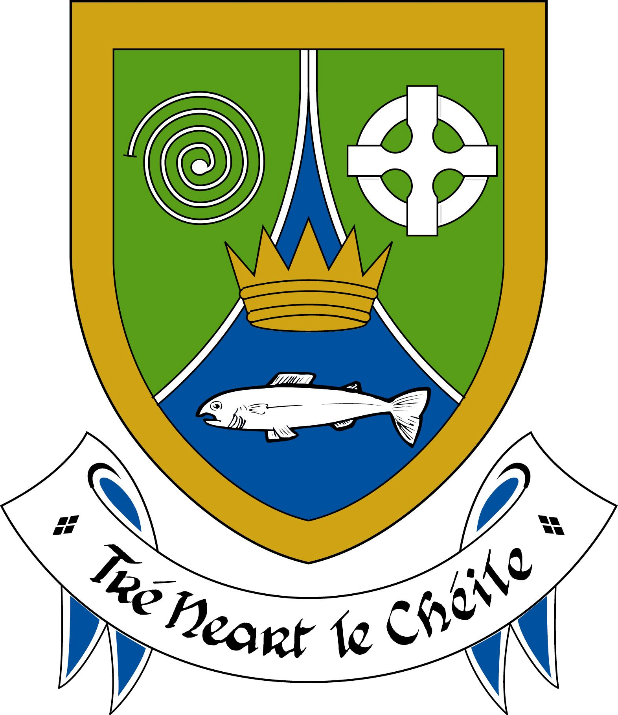

Procedure for application for Exhumation License
Introduction
Meath County Council (hereafter ‘the Council’) has the authority to issues licenses which authorise the exhumation of remains. Exhumation licenses are only issued where applications for the exhumation of interred remains comply with very strict guidelines/license conditions (including permission granted by the family).
Exhumations may only take place in the presence of a HSE Environmental Health Officer and the exhumation must be supervised to ensure privacy and to protect public health.
The legislation governing exhumations in Ireland is Section 46 of the Local Government (Sanitary Services) Act 1948 as amended by Section 4(2) and the Second Schedule of the Local Government Act, 1994.
An exhumation license will not be granted where:
- The consent of the next of kin has not been given
- The burial plot cannot be identified
- The remains lie unidentified in a common plot (e.g. the burial plot of a religious order)
- Due respect to the deceased cannot be guaranteed
- The remains to be exhumed are located below a body that is not to be exhumed
- Public health and decency cannot be protected
- Burial ground conditions are not conducive to an exhumation
- Conditions attached to the exhumation license cannot be complied with.
Application for exhumation license
An application for an exhumation license should be made to the Council (issued and administered from the Environment Section) and must be accompanied by the following:
- The completed application form
- A copy of the Death Certificate of the deceased person
- A completed certificate from the Director of Community Care and Medical Officer of Health.
- A completed form of consent from the authority in control of the burial ground.
Queries in relation to the issue of exhumation licenses should be addressed to the Environment Section, Meath County Council.

Environmental health and exhumations
When a request for an exhumation is received by the Council, the application is forwarded to the HSE Environmental Health Section for their consideration at which point a HSE Environmental Health Officer will visit and inspect the grave of the deceased person and obtain any further information required from the authority in control of the burial ground and the undertakers involved. The HSE Environmental Health Section will then make a recommendation in relation to the exhumation license application. The HSE Environment Health Section will also recommend to the Council conditions to be attached to the exhumation license if it recommended to authorise same.
The HSE Environmental Health Officer will then be present at the exhumation and will supervise the events in order to ensure that respect for the deceased person is maintained and that public health is protected.
If the remains are to be re-interred in Co. Meath, the HSE Environmental Health Officer will also supervise the re-interment. If the remains are to be re-interred in another local authority area, the HSE Environmental Health Officer will ensure that the receiving local authority receives all necessary details.
During the course of the exhumation, the HSE Environmental Health Officer ensures that:
- The correct grave is opened
- The exhumation commences as early as possible in the morning to ensure maximum privacy
- The plot/burial ground is screened as appropriate
- All workers wear protective clothing, including gloves, overalls, face masks, etc.
- Everyone present shows due respect to the deceased person
- The name plate on the casket corresponds with the name on the license
- All remains and pieces of casket, webbing etc. are placed in the new casket (shell)
- A supply of disinfectant is available and used.

Exhumation of interred remains
When an exhumation license has been authorised and granted by the Council, the exhumation of the interred remains must take place within 12 months of the granting of the license.
The time, date and place of exhumation must be notified to the HSE Environmental Health Section at least five working days prior to the exhumation (this is to ensure that inspection of the plot/grave can take place). Arrangements regarding the transportation and storage of remains between the period of exhumation and re-interment should also be notified to the HSE Environmental Health Section.
Exhumations cannot take place unless a HSE Environmental Health Officer is present. This is to ensure that all procedures and the terms of the exhumation license as granted by the Council are complied with and that everyone present shows respect to the deceased person at all times.
Screens are placed around the existing grave/burial plot to protect the exhumation from public view and to guarantee privacy and if necessary, the burial ground may be closed to the public or an area of the burial ground may be cordoned off from public view to facilitate privacy.
Disinfectants and disposable protective clothing (including respiratory facemasks) are made available to staff conducting the exhumation and any used protective clothing is disposed of safely following the procedure.
The exhumed remains (including the existing casket) are placed in a new casket (sometimes this is referred to as the ‘shell’). This new casket (or shell) is made of timber, tarred on the inside, followed by a zinc liner and then covered inside by a leak-proof plastic membrane. The zinc liner lid is sealed with isopon (a sealant). The new casket lid is then screwed or nailed in place and a nameplate giving the name and date of death of the deceased person is attached to the exterior lid of the coffin.
Any other remains in the same burial plot that may have been disturbed during the exhumation process are re-interred in accordance with public decency and respect.
For any further or related information please contact the Environment Section, Meath County Council at: 046 9097200.

Environment Section
Meath County Council
Railway Street
Navan
Co. Meath

Ph: 046 9097200
Email: environment@meathcoco.ie

