ShareFile User Guide – External Client
In order to upload documents for lodging planning applications or further information you are required to follow the steps below:
- Email planning@meathcoco.ie to request a secure link to upload your files.
- You will receive and email that includes a secure link that will look similar to the following:
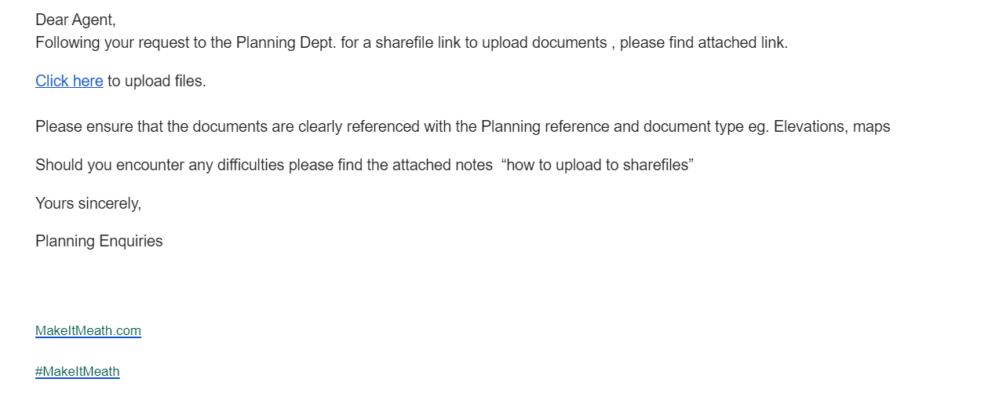
- Click on the secure link “Click here to upload files”. This will launch your web browser and bring you to Meath County Council’s Sharefile platform.
- You will be prompted to enter your name, your email address and company name. Click Continue.
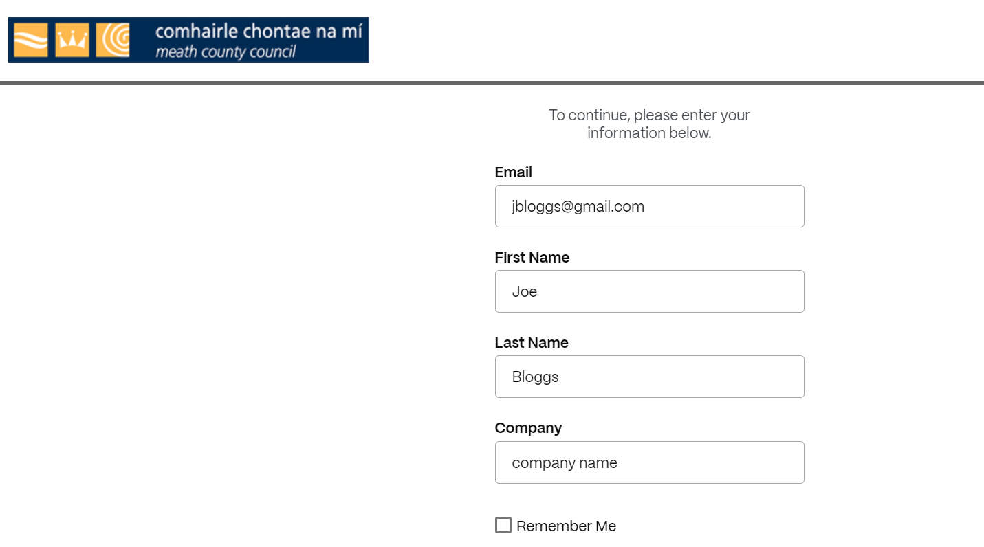
You will then see the following screen.
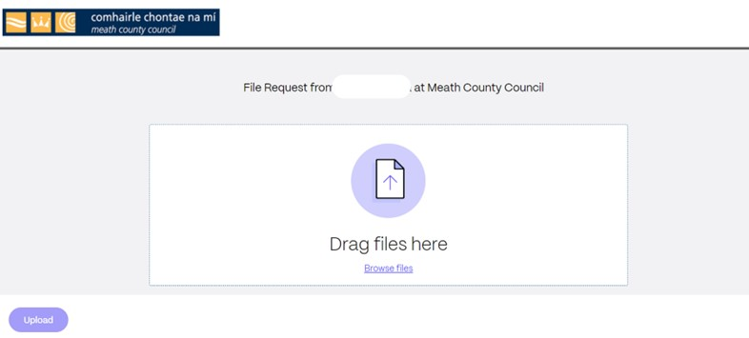
- Click on Browse Files and select From PC. This will launch your file explorer where you can navigate to where the files are located.
Highlight the files to be uploaded and click Open.
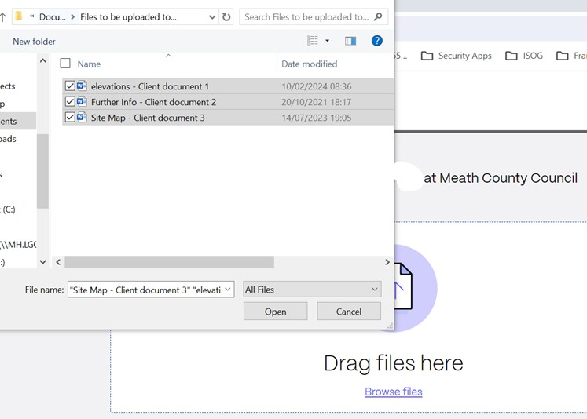
- The files to be uploaded will be listed in the ShareFile platform. Click on Uoload to start uploading the files.
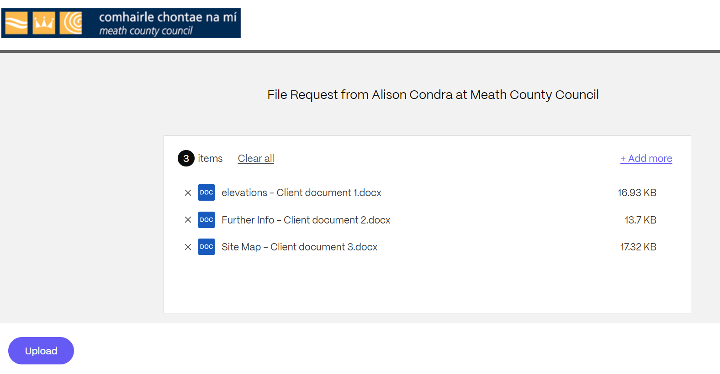
You will see the progress of the uploads displayed and it will show you when it has completed.
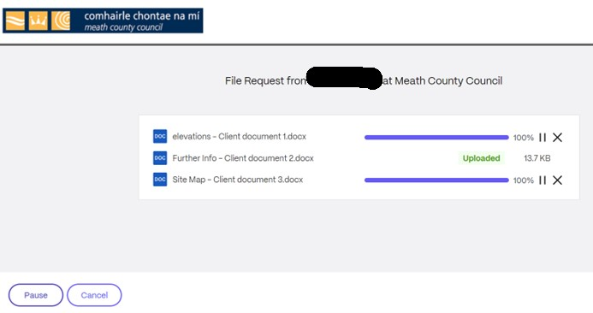
- Once all documents displayed have been marked as uploaded you can click the “x” at the top right of the browser to close it.
- The planning section will receive an alert from ShareFile to notify them that files have been uploaded.
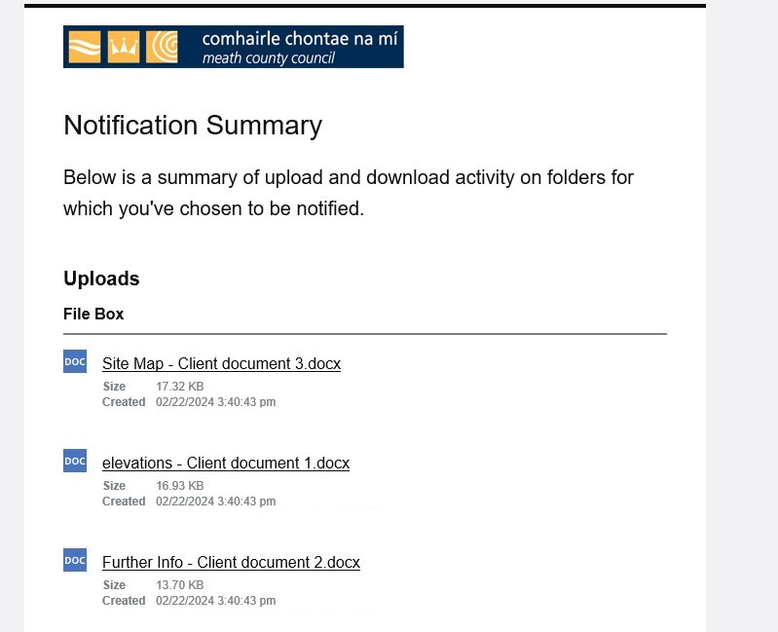

Or further information on how to upload to Sharefile you can visit https://www.sharefile.com/training .

